Time & Priority Management

Sidra Medical & Research Center
Email: rpeden

Workshop Agenda
Introduction
Jar Exercise
SMART Goals & Focus
Priority Matrix
Planning Your Week
Time Bandits
Managing Interruptions
Workspace & Email Management
Wrap-up

Course Developed by
Ryan Peden
Educator – Corporate Programs

Contact Information
Organizational Learning
sidralearning@sidra.org
Learning Outcomes

On successful completion of the course the participant will learn:

- To understand and identify priorities at work and how SMART objectives help create focus
- How to use practical time management tools to focus on priority tasks
- To organize workspaces and email for maximum efficiency
- Techniques and strategies to avoid time-wasters and interruptions

Jar Exercise

How can you fit in objects of varying sizes into the jar most effectively? What order did you put them in?

What can you take away from the Jar Exercise?

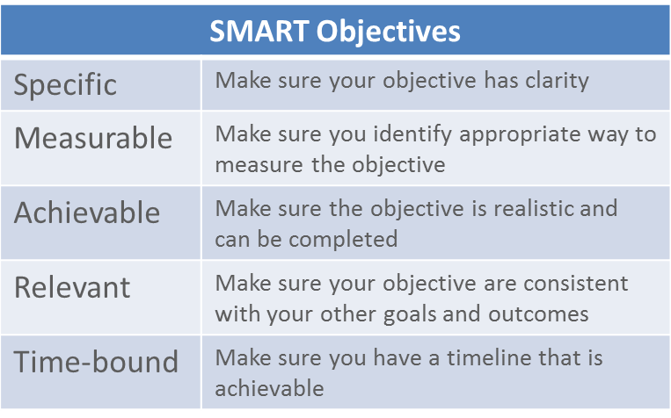

Not a SMART objective
Write Sidra policies.
SMART objective
Complete all policies required for opening the department by March 2015.
Not a SMART objective
Deliver timely support services that satisfy my internal customers.
SMART objective
Achieve a 90% satisfaction rating for support services delivered with an average delivery time of 2 days per request, for all services delivered between August 2014 and July 2015.

What are your workplace SMART objectives?

Comparing to your activities over a typical 2 day period, how much of what you do is directly linked to your SMART objectives?

Urgent and Important Tasks

Urgent Tasks
- Demand immediate attention
- Often associated with someone else’s goals
- Often what we concentrate on the most
- Consequences of not acting on these tasks are more immediate
Important Tasks
- Have outcomes that relate directly to the achievement of your goals
- Can be both professional and personal goals
- May not be as immediate in focus

The Priority Matrix

General Notes:
- Sourced from the Seven Habits of Highly Effective People by Stephen Covey
- People who are poor at time management spend most of their time in Quadrants 1 and 3
- You should spend most of your time on Quadrant 2 activities as these bring longer term results

Quadrant 1: Do Now
- Both important and urgent
- Items that need to be dealt with immediately and should be your first priority items
- Examples:
  - Emergencies and crisis issues
  - Information demands from superiors or customers
  - Urgent complaints
- Tips for managing Quadrant 1 tasks:
  - If you have multiple Quadrant 1 tasks, prioritize by relative urgency
  - Identify actual urgency by probing task originators about actual requirements and deadlines
  - If an unplanned tasks, try to break into two, dealing with most urgent need and plan to do the remainder of the task at a later date, making it a Quadrant 2 task

Quadrant 2: Plan To Do
- Important but not necessarily urgent
- Items that need to be planned for, and contribute to the long-term achievement of goals, but often the most neglected
- Examples:
  - Preparation and planning
  - Research and investigation
  - Strategy development
- Tips for managing Quadrant 2 tasks:
  - Plan timeslots for these tasks
  - Inform others of your schedules to ensure work is uninterrupted, e.g. a visible schedule
  - Consider working in a quiet place
  - Break bigger tasks into smaller tasks and plan timeslots for each

Quadrant 3: Reject Nicely
- Urgent but not important
- These kind of tasks should be minimized or eliminated
- Examples:
  - Trivial or off-loaded requests from others
  - Ad-hoc interruptions
  - Pointless meetings, i.e. no agenda or outcomes
- Tips for managing Quadrant 3 tasks:
  - Where possible, reject politely and diplomatically
  - Explain why you cannot complete these tasks and help find another solution, may include delegating to someone else, or reshaping task to be more strategic
  - If faced by repeating Quadrant 3 demands, create a project to resolve the root causes

Quadrant 4: Resist and Avoid
- Neither urgent nor important
- Trivial time-wasters with little or no added value
- Examples:
  - Internet surfing
  - Irrelevant emails
- Tips for managing Quadrant 1 tasks:
  - Activities have no positive outcomes, so time wasted on them becomes demotivating
  - Often related to stress or frustration, if there is a deeper root cause, address it
  - Resist temptation by having a clear structure and schedule for daily tasks

Your Priority Matrix (Your Past 2 Working Days)
Do Now | Plan To Do
Reject Nicely | Resist and Avoid
Your Priority Matrix (Looking Forward)
Do Now | Plan To Do
Reject Nicely | Resist and Avoid

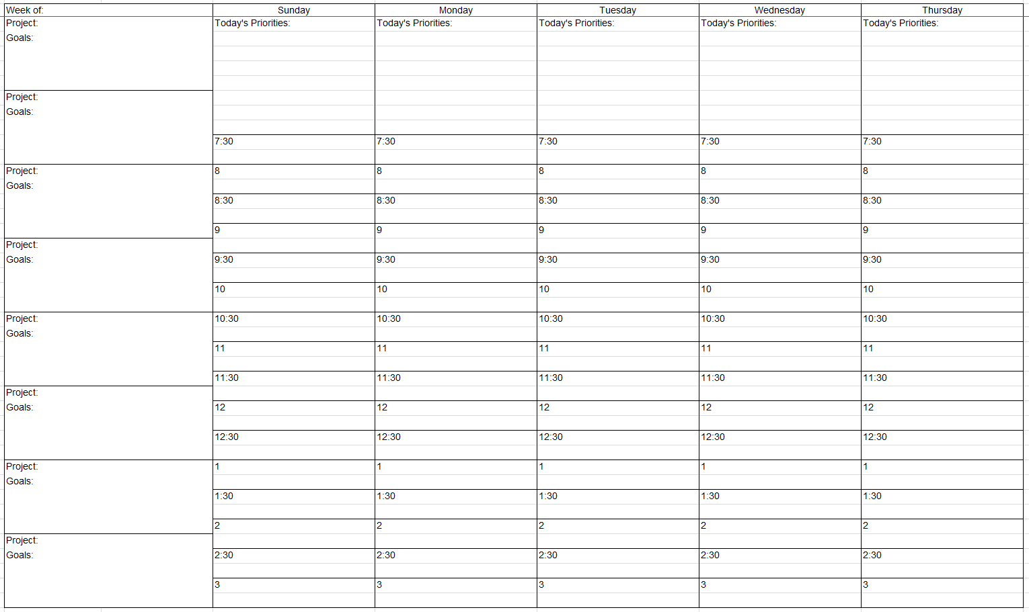
Time Bandits
Time Bandit 1:

Time Bandit 2:

Time Bandit 3:

Time Bandit 4:

Time Bandit 5:

Other Notes:

Interruptions

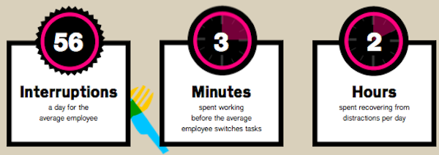

Unnecessary Interruptions  - Deal with these politely but assertively  - It’s often acceptable to say “no” to requests and tasks if:  - You are busy  - Someone else can handle it  - It isn’t important  - It can be done later | Uncontrollable Interruptions  - No matter how hard you try there are still interruptions  - Ask to schedule a more convenient time  - If it has to be done now, quickly set boundaries  - For example, say you have 5 minutes and stick to this!
Urgent and Valid Interruptions  - May be pre-empted by having routine meetings  - Plan for how much time these interruptions take each week and plan time in schedule to deal with them  - Handle urgent issues as they arise but help others be as effective as possible to avoid ongoing interruptions | Phone Call Interruptions  - Consider silencing your mobile phone and forwarding calls to voice mail  - That way you can deal with calls by priority and at times that suit you  - Especially important when you have scheduled time for Quadrant 2 tasks

Interruption Scenarios

Think of some examples of common interruptions:

Notes from Role Play:

Workspace Management

Misplaced items cost us ten minutes a day
Assuming half of that is while at work, that’s nearly 1300 minutes a year, or about half a 40 hour work week

How would you move from the messy workspace to the tidy workspace pictured?

Email Management

Reclaim Your Inbox!

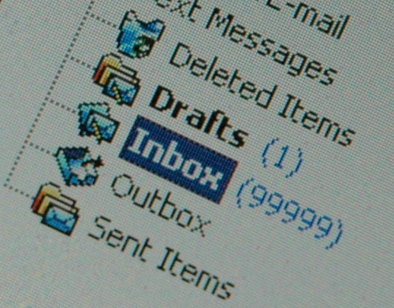
Step 1: Reduce Email to Your Inbox

- Turn off social media notifications
- Unsubscribe from lists
- Set up a separate email address
- Set up filters
Step 2: Manage Your Emails

- Step up a folder system
- Check emails intermittently
- Scan and Action (the 2 minute rule)
- Respond at set times

Notes:

Notes:

Notes:

Notes:

